**Builder Listing**

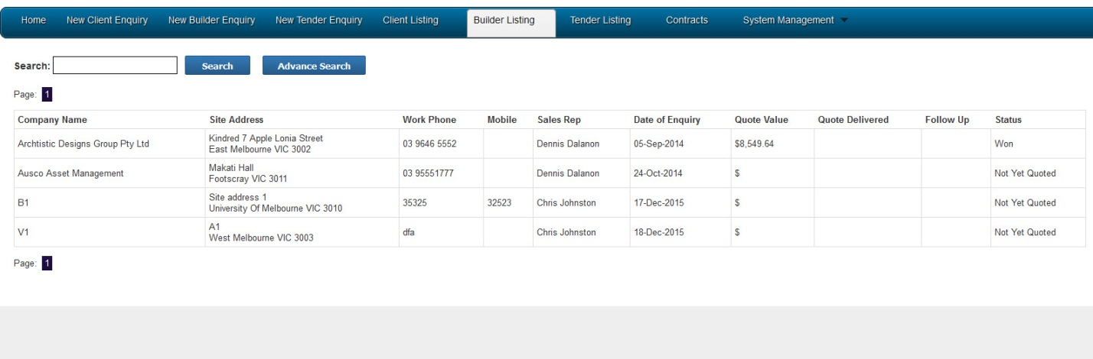

**List of files that are used for this section**

builder_listing_vic.php

new_builder_enquiry_vic.php

**List of tables used.**

ver_chronoforms_data_builder_vic

**Any plugins we used**

(Basic Joomla CMS)

**List of required fields**

Project name, framework type, length, length 2, width

**List of business rules**

**Builder Quote**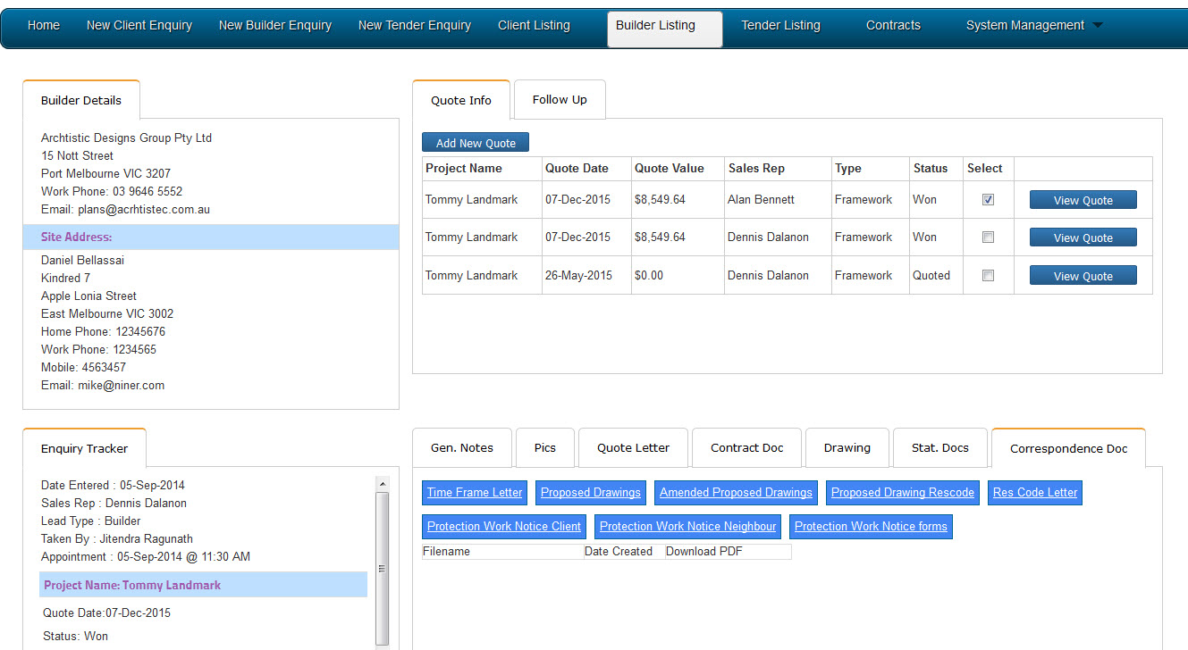

**Add New Quote**

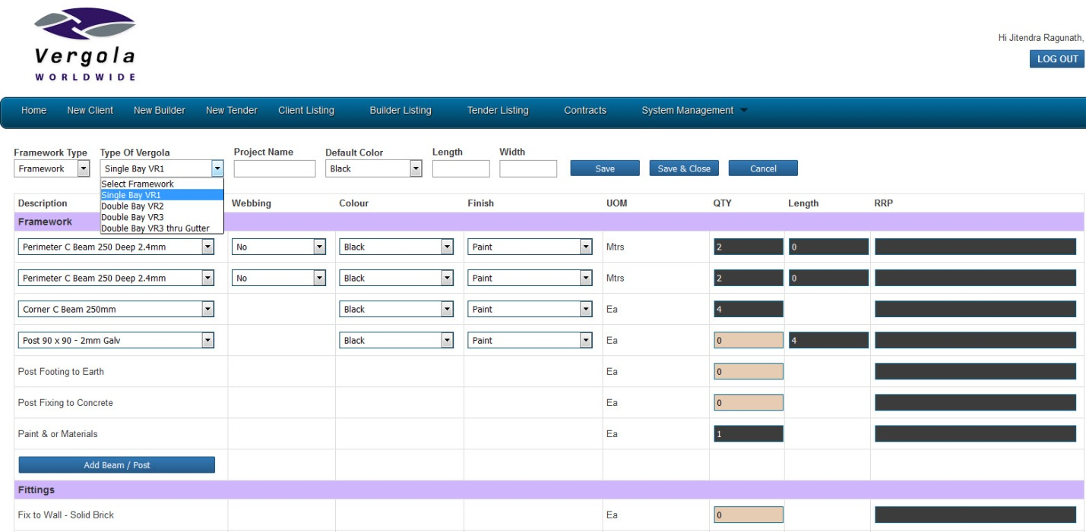

**List of files that are used for this section**

project_folder/includes/vic/quote/singlebay_vic_vr1.php

project_folder/includes/vic/quote/doublebay_vic_vr2.php

project_folder/includes/vic/quote/doublebay_vic_vr3.php

project_folder/includes/vic/quote/doublebay_vic_vr3_thru_gutter.php

**List of tables used**

ver_chronoforms_data_builder_vic

ver_chronoforms_data_followup_vic

ver_chronoforms_data_quote_vic

ver_chronoforms_data_inventory_vic

ver_vergola_default_framework_items

**Any plugins we used**

(Basic Joomla CMS)

**List of business rules**

A contract can’t be created without selecting a checkbox of a quote created.

Select a quote to make a quote letter, Contract Doc, Stat Docs, and Correspondence doc.

**List of required fields.**

Project name, framework type, length, length 2, width